# MSDM5003 Final Project

Evolutionary prisoner’s dilemma game on a square lattice

Zhang Mingtao

## 1 Introduction

The Evolutionary Prisoner's Dilemma Game is a classic game used to study the conflict between cooperation and competition. Participants in the game is faced with the decision to cooperate or to defect. The prisoner's strategy can be passed on to future, making the evolution of the strategy possible. After each round, the prisoners' strategies are evaluated and chosen based on the results of their interactions. The more successful strategy will have a higher chance of survival and reproduction.

## 2 Model

The players located on a square lattice can follow only two simple strategies: C (cooperate) and D(defect). Assuming the players get rewards **R/P** if both choose to **cooperate/defect**. In the remaining two cases the defector’s and cooperator’s payoff are **T(temptation to defect)** and **S(sucker’s payoff)**, respectively. We limited that **T>R>P>=S**, and **2R>T+S**. To simplify we choose **R=1, P=S=0, and T=b, where b >1**. Thus the payoff to player A against B is given 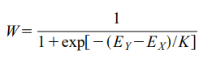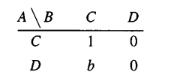by the matrix in Fig. 1. :

**Fig. 2. X’s probability to change to Y’s.**

**Fig. 1. A’s Payoff against B.**

We consider two systems. In the first system, we only consider the influence of the four neighbors(above, below, left, and right), and in the second system, we consider the influence of the eight surrounding neighbors.

The randomly chosen player X revises its strategy according to the following rules: This player selects one of its neighbors Y with equal probability. Given the total payoffs(EX and EY) from the previous round, player X adopts the

neighbor’s strategy with the probability W in Fig. 2., and **K** characterizes the

noise introduced to permit irrational choices, the smaller **K** is, the more likely X is to choose Y’s strategy.(0<**K**<1)

## 3 Goal

For both systems, the uniform cooperation (all C) is a stable state if **b** does not exceed a threshold value **b_c1** that is larger than 1. This means that any constellation of defectors will be defeated if **b<b_c1**. In the same way the all D state remains stable for **b>b_c2**. Henceforth we will concentrate on those

states where the cooperators and defectors can coexist(**b_c1<b<b_c2**).

When coexisting, under the condition of initial random allocation of strategies, after more than ten rounds of strategy evolution, **the overall density** of collaborators in the **L×L** grid tends to be stable, which we mark as **c**. We use the field mean approximation theory, use **c** to represent an individual's final choice trend in this model, and explore the relationship between **c** and **b**.

## 4 Results

## 4.1 Model1: 4 neighbours, L=100, K=0.1

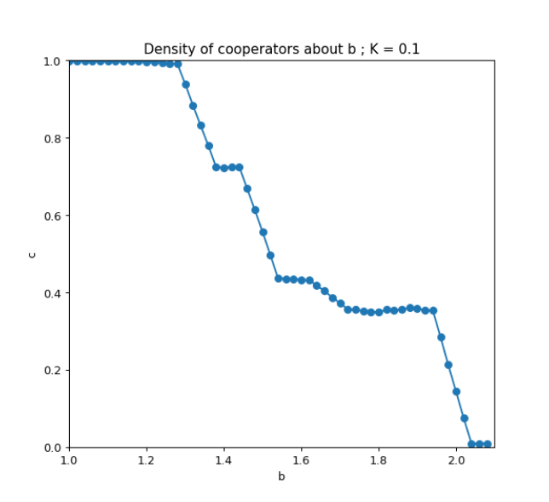

**Fig. 3. Density of cooperators as a function of temptation to**

**defect for 4 neighbours, L=100, K=0.1.**

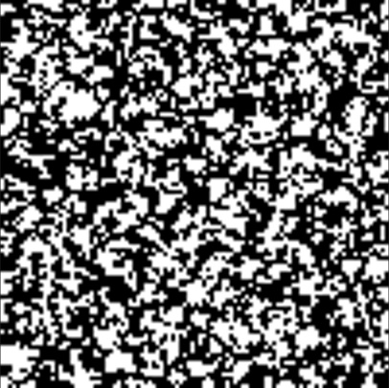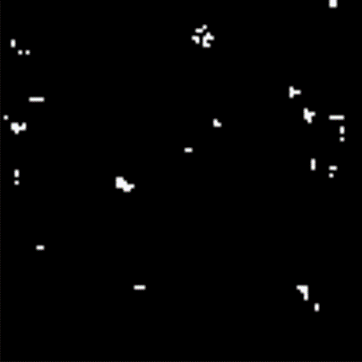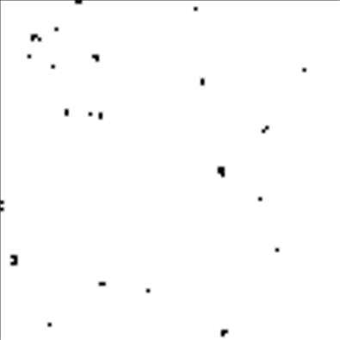First we consider the model with 4 neighbours’ interactions. Fig. 3. shows the **c-b** relationship in the coexistence region for **K=0.1**, **c** decreases with increasing **b** until the second threshold **b_c2** , where the cooperators vanish. The sharp steps appear at the break points like b=4/3, 3/2.

**Fig. 4.3. Cooperators (white) form colonies in the sea of**

**Defectors(black) when c→0.**

**b=2.0, K=0.1**

**Fig. 4.2. Defectors(black) form gangs in the sea of**

**Cooperators (white) when c→1.**

**b=1.24, K=0.1**

**Fig. 4.1. Distribution of cooperators (white) and defectors (black). b=1.54, K=0.1, c=** **0.443**

We can use simulated data to fit the **c-b** curve, but first we must ignore the situations when **c** tends to 0 or 1. Because the premise of mean-field approximate field theory is overall uniformity, but when **c** tends to 1 or 0, the distribution of defectors or cooperators is clustered. The mean-field approximations are not able to handle with the long-range correlations. These **gangs** or **colonies** will walk randomly, suddenly appear or disappear as the simulation proceeds. In these **c**→0/1 cases, our simulation curve cannot really predict an individual’s strategic expectations. Examples can be seen in Fig. 4.2 and Fig. 4.3.

Our MC data shown in Fig. 3 refer to a power-law behavior:

$$c∝{\left(b_{c_{2}}-b\right)}^{β}, b→b_{c_{2}} \left(1\right)$$

$$1-c∝{\left(b-b_{c_{1}}\right)}^{β}, b→b_{c_{1}} (2)$$

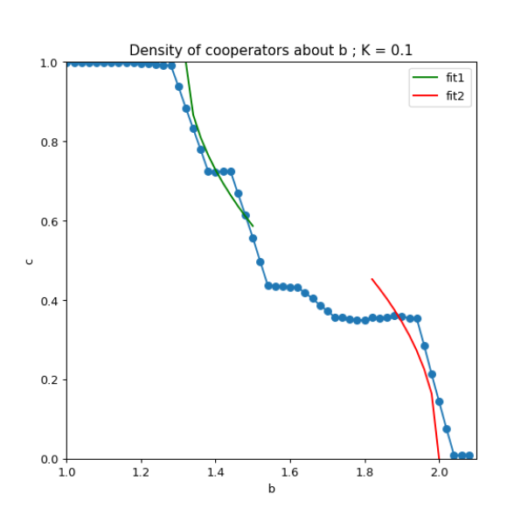The best fit for equation (1) is obtained for **b_c2**=2.0 and **β**=0.462; The best fit for equation (2) is obtained for **b_c1**=1.32 and **β**=0.515. As Fig. 5. shows.

**Fig. 5. Fit curve about the c-b data for 4 neighbours, L=100, K=0.1.**

## 4.2 Model2: 4 neighbours, L=100, K=0.5

When we increase the calue of K to make more random noises when evolving strategies, the data seem to be more smoooth as Fig. 6. shows.

The best fit for equation (1) is obtained for **b_c2**=2.0 and **β**=0.514; The best fit for equation (2) is obtained for **b_c1**=1.30 and **β**=0.554.

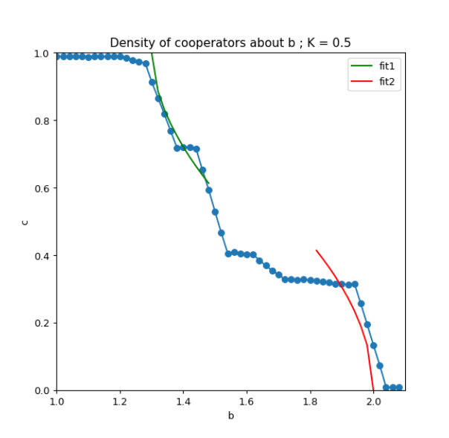

**Fig. 6. Fit curve about the c-b data for 4 neighbours, L=100, K=0.5.**

## 4.3 Model3&4: 8 neighbours, L=100, K=0.02&0.5

For the second system, we consider the surrounding 8 neighbours and get two **c-b** plots of **K**=0.02 and **K**=0.5 as Fig. 7. And Fig. 8. shows. Compared with the first system, the fault frequency of **c** is higher and the decline speed is faster. The thresholds **b_c1** and **b_c2** are significantly reduced:

**K**=0.02: **b_c2**=1.520 and related **β**=0.441; **b_c1**=1.152 and related **β**=0.410.

**K**=0.5: **b_c2**=1.504 and related **β**=0.428; **b_c1**=1.144 and related **β**=0.424.

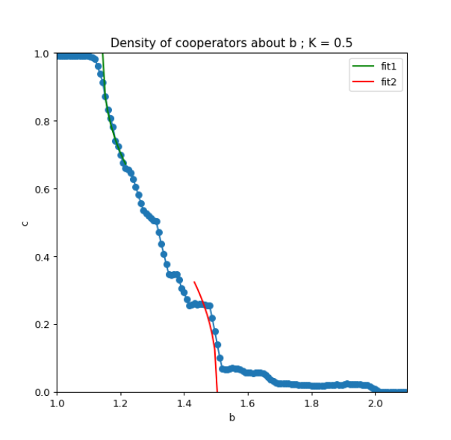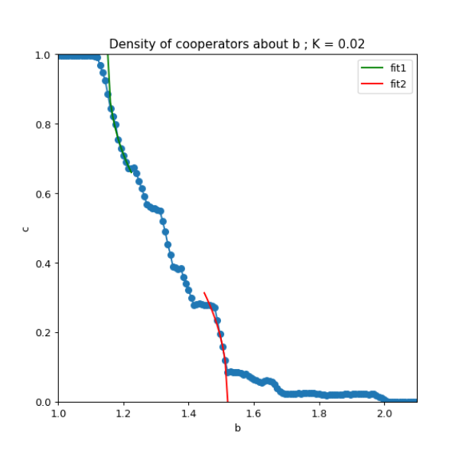

**Fig. 7. Fit curve about the c-b data for 8 neighbours, L=100, K=0.02**

**Fig. 8. Fit curve about the c-b data for 8 neighbours, L=100, K=0.5.**

## 5 Conclusion

When the defector rate **b** is too high or too low, the final result of the strategy evolution will be all cooperation or all deception. When both states can coexist, **b** is within a threshold range: **b_c1-b_c2**, and the values ​​of both 2 thresholds decrease as the number of neighbors we considered increases. No matter which system, the relationship between the final collaborator density **c** and the cheating benefit **b** can be fitted and predicted through the power law formula: $c∝{\left(b_{c_{2}}-b\right)}^{β}, b→b_{c_{2}}$ and $1-c∝{\left(b-b_{c_{1}}\right)}^{β}, b→b_{c_{1}}$. As the random disturbance **K** increases, this fitting curve will be more reasonable and accurate. However, it It does not apply when **c** tends to 0/1, where mean-field approximate field theory shows its limitation.

## Appendix

Computer codes (see the code file)

Results rar. to see all gifs

## References

[1] Gyo¨rgy Szabo´ and Csaba To˝ke, Evolutionary prisoner’s dilemma game on a square lattice, Phys. Rev. E, 58 (1998) 69